General description:

A web store application for products acquisition.

The purpose of this project is to allow the store owner to upload the products he wishes to sale, trace the clients orders and send the products to the clients.

Entrance as an unregistered client

When client first visits the website it is necessary to register or login.

Client who is not registered in the database will not be able to purchase the products that are shown on the website, but only to see the products and the products details.

*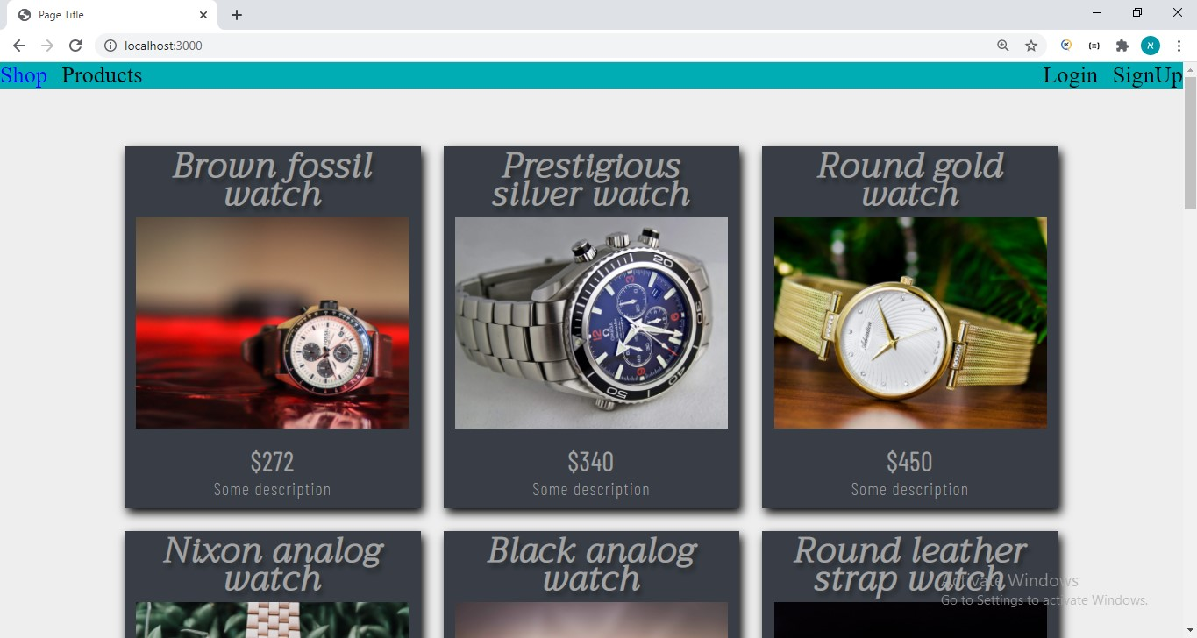Here is an example for the home page where unregistered clients can see the products uploaded by the store owner*.

*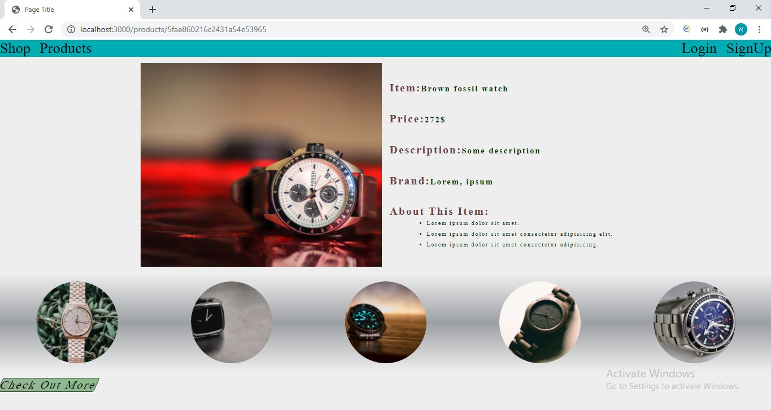Example of a page where the details of the product is shown*

Entrance as a registered user

when client is logged in, he will be able to add products he wishes to purchase to his cart. When client is done with his shopping, he will press the Order button and will be redirected to the orders page, from there, he will be able to see his orders details, download the receipt for the order and dummy pay for it.

*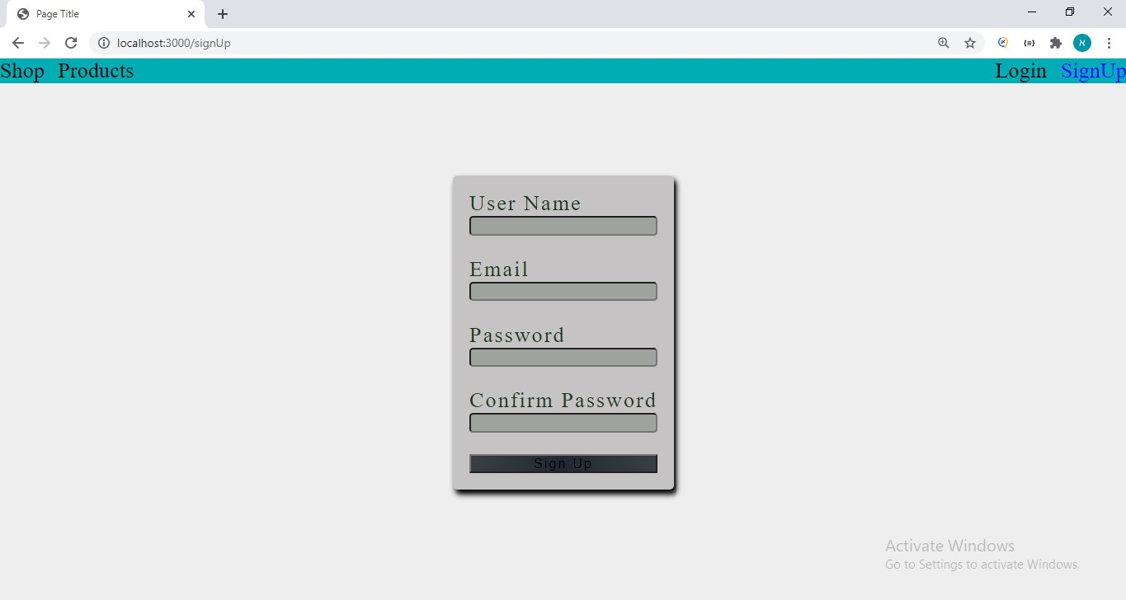Registration page:*

*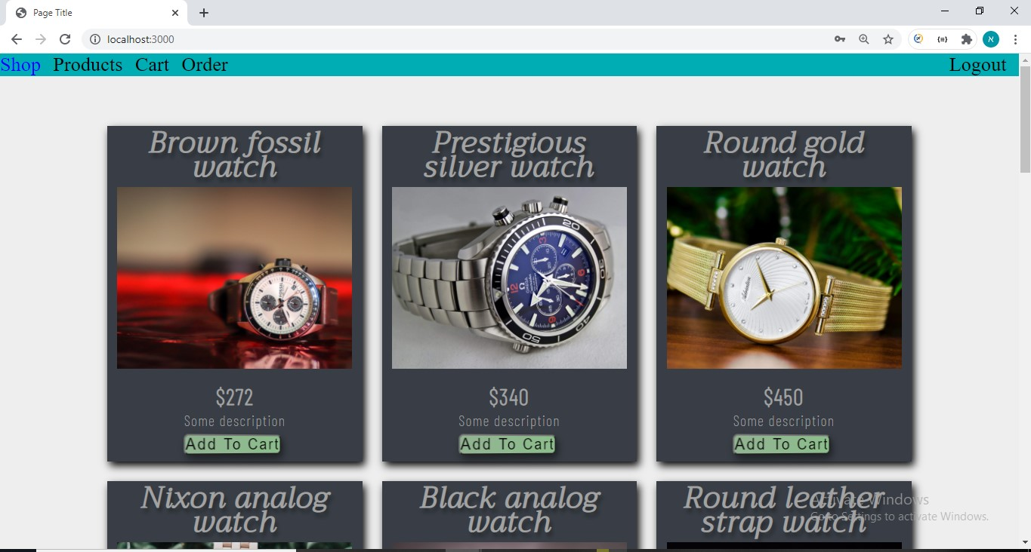The rendered page for a logged in client*

*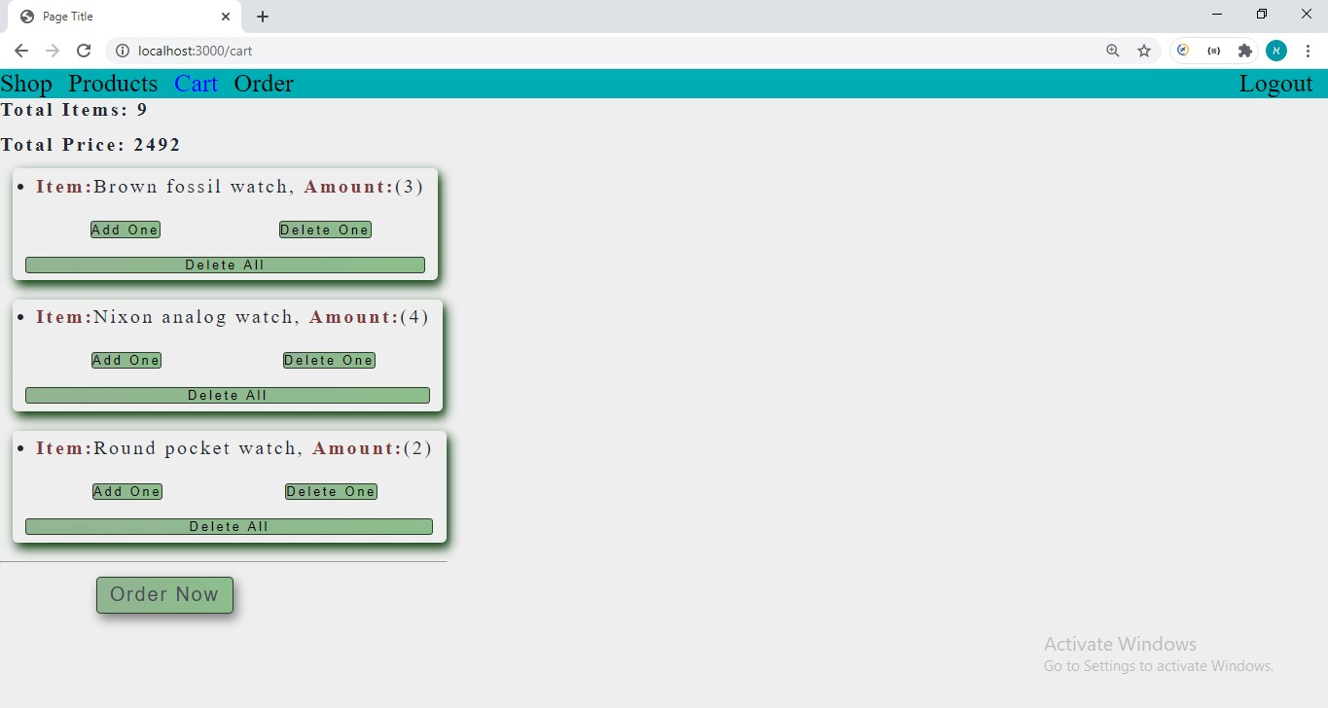Client’s cart*

*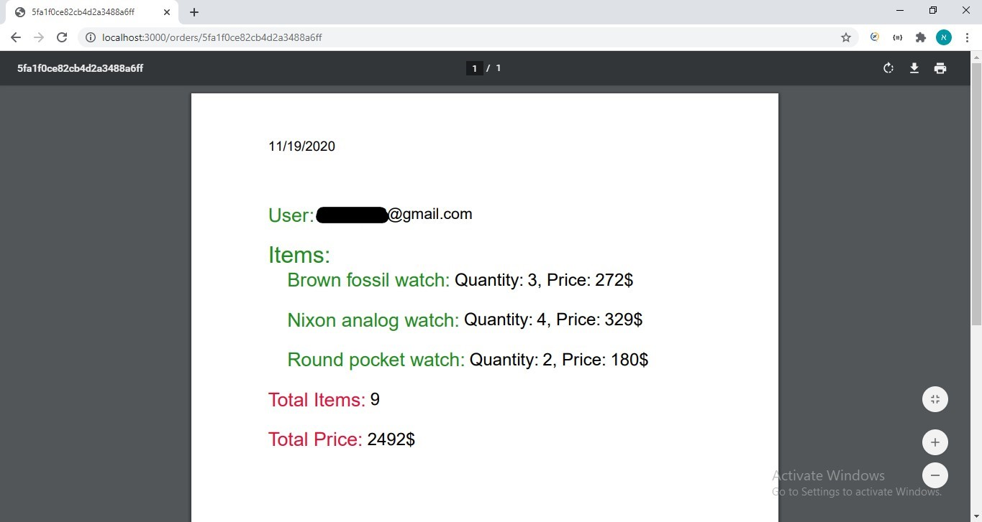Order receipt*

*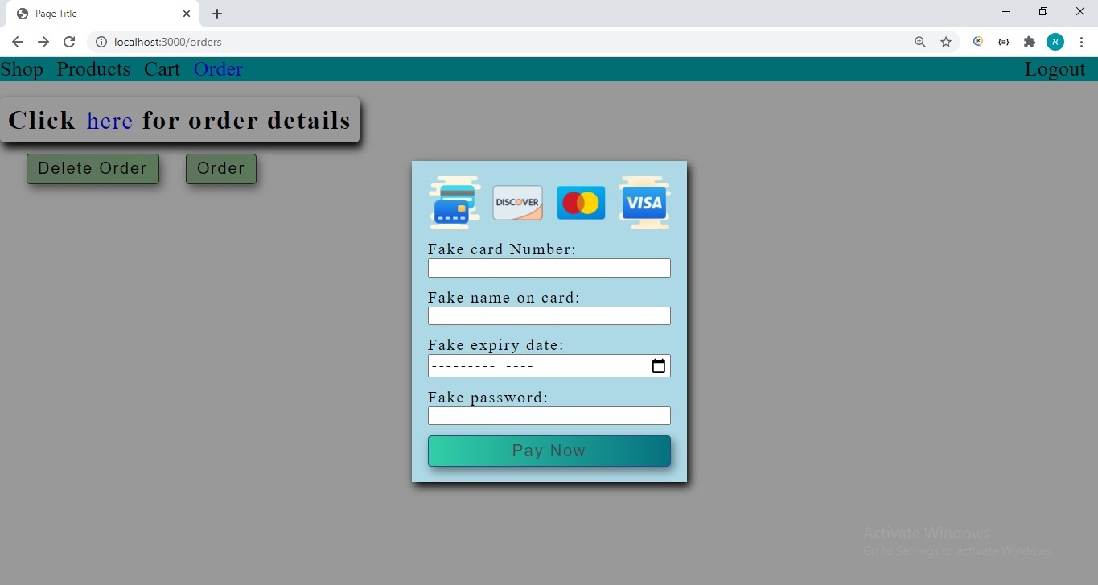Payment*

Store Owner

When the owner of the store enters his email and password, the system will identify him as the owner and the functionality of the program will be different to the owner from the other clients.

The store owner will be able to upload new products, change them (price, description, image) and delete them.

In addition, he will be able to track new orders and receive an alert when a new order comes in.

Likewise, he will be able to manage his clients such that if he needs to, he will be able to send mail to the client, check the history of the client orders and remove the client from the database.

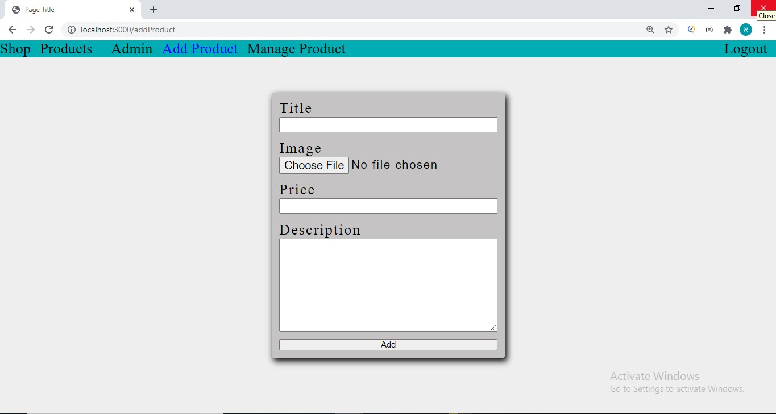*Upload new product*

*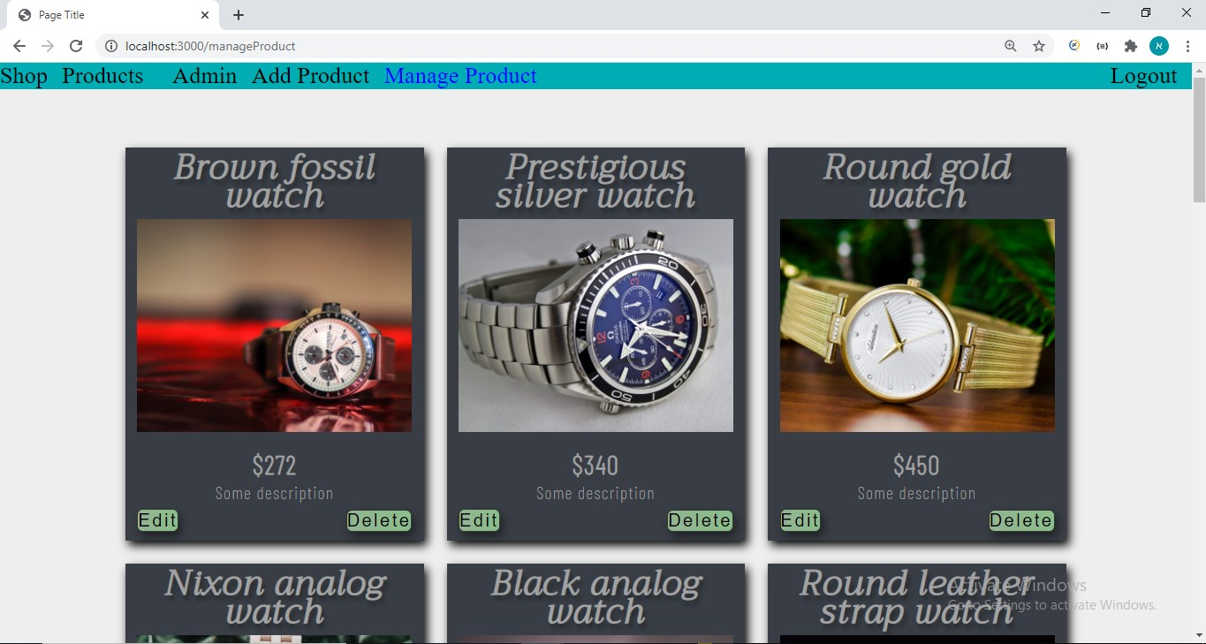Change/delete product details*

*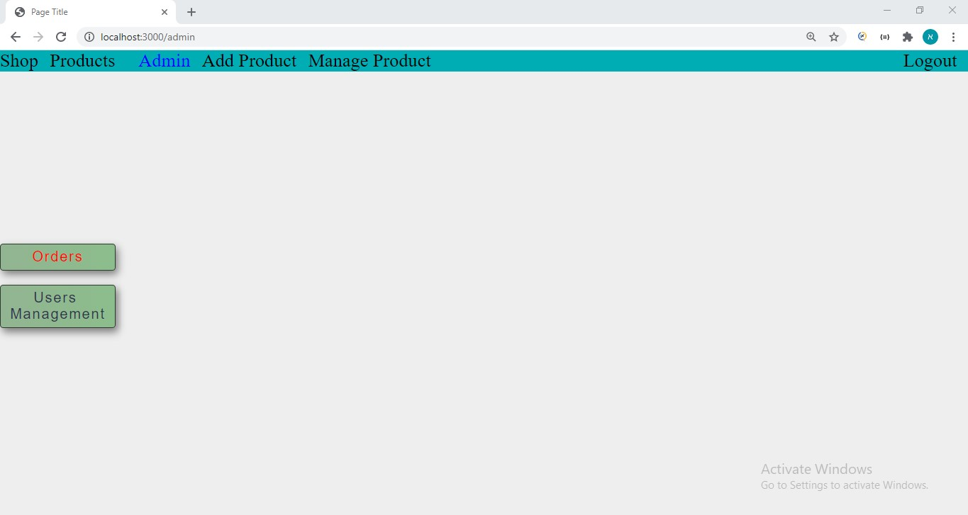Users management button and order button that flashes for every new coming order*

*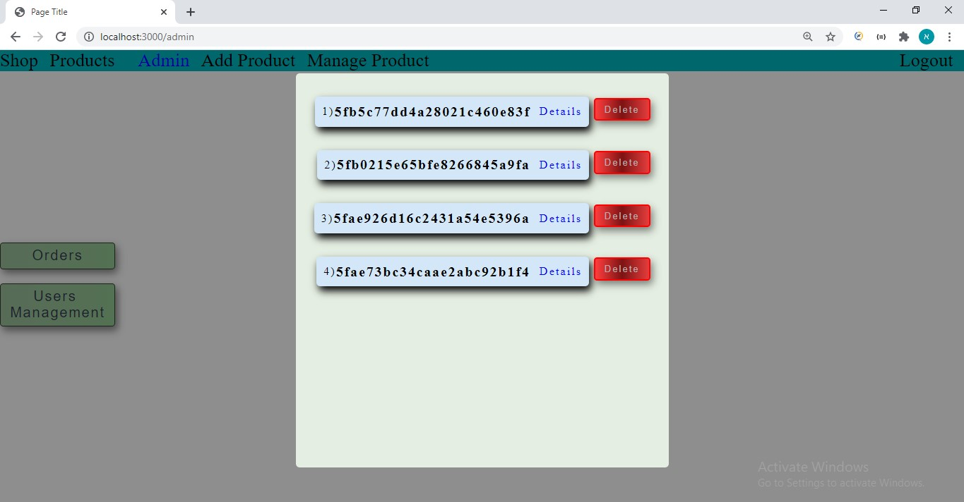order button was pressed*

*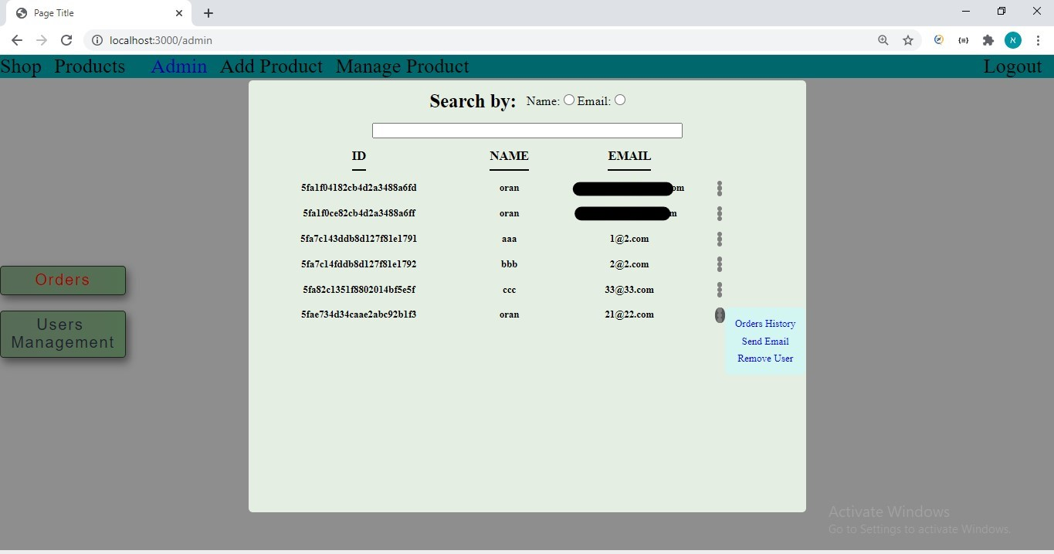users management button was pressed*